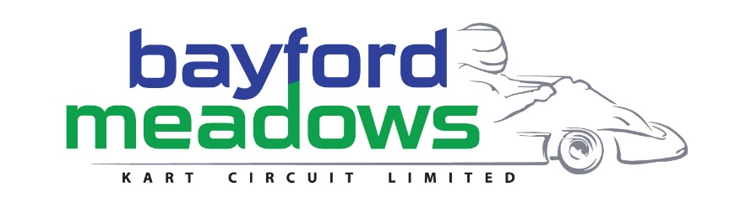

Booking Form

Company ...........................................................................
Contact ...........................................................................

Telephone ...........................................................................

Email ...........................................................................

Address: ...........................................................................

...........................................................................

...........................................................................

Invoice Address ...........................................................................
(if different)
...........................................................................

...........................................................................

I confirm that I would like to provide an advertising board (not banner) complete with artwork, size: 3ft x 16ft / 1100 x 4800 to be installed circuit side at Bayford Meadows Kart Circuit Ltd. I agree to pay £200 + VAT per year.

Signed .................................................................

Position .................................................................

Date .................................................................

